**Shabbos Stories For**

**Parshas nitzavim 5785 &**

**rosh hashana 5786**

Vol 16, Issue 51/Vol 17, Issue 1 27 Elul 5785/Sept 20 & 1 Tishrei/Sept 23-24, 2025

**Printed L’illuy nishmas Nechama bas R’ Noach, a”h**

For a free subscription, please forward your request to ***keren18@juno.com***

***Past emails can be found on the website – ShabbosStories.com***

**The Humiliated Brother**



In one of the famous, larger Shuls in Yerushalayim, there are many different Minyanim that take place in different parts of the Shul building, and there are two brothers who run from Minyan to Minyan throughout Rosh Hashanah, and blow Shofar for all the Minyanin.

One year, when one of the brothers got up to blow Shofar, it just wasn’t working out for him. He tried to clean the Shofar and do everything he could to make the proper Shofar blasts, but nothing helped, and the people in the Minyan began losing patience.

Eventually, the other brother came in and saved his brother, and blew the Tekios for that Minyan. After Davening, the brother who couldn’t blow the Shofar well went home, slightly embarrassed, and feeling bad that he caused his brother to work harder. After blowing Shofar for the last Minyan, the second brother went straight to his brother’s house to check on him and try to cheer him up after his humiliating experience. He told his brother that it could happen to even the most experienced Baal Tokei’a, and there was really nothing to be ashamed of.

The first brother smiled and shrugged it off. He said, “While humiliation is the most difficult thing in the world to deal with, I accept it with Simchah.” He continued, “You, my brother, have three older, unmarried children in your home. I am giving you my Zechus of accepting my shame with love. In that merit, all three of these children should all be Zocheh to get married this year!” Within a few short months, Baruch Hashem, all three children got married, one after the other!

*Reprinted from the Rosh Hashanah 5785 email of Rabbi Yehuda Winzelberg’s Torah U’Tefilah.*

**Laurie Fogel’s “Long” Wait**

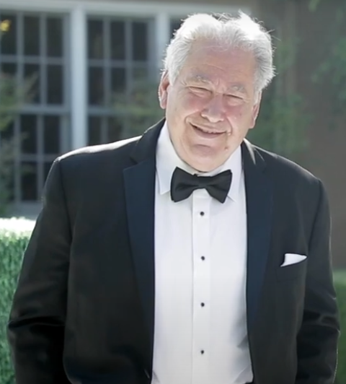

**Laurie Fogel and Ron Hass**

The Torah reminds us constantly that Hashem is in control, running the world, creating intricate, knotted webs that come together to make miraculous stories. Rabbi Yoel Gold told an inspiring story in his video series, The Wait, about a woman who never lost emunah that Hashem would bring her naseeb—match.

At 64 years old, Laurie Fogel had been in shidduchim for over 40 years. Her mom, constantly filled with emunah, supported Laurie through her many years of dating by saying Tehillim and assuring Laurie that Hashem runs the world and that He will send her a match at the right time.

One day, Laurie’s mom suddenly had a heart attack. The doctors worked on her tirelessly in Cedars-Sinai Medical Center in Los Angeles and managed to get her stable, B’H. On May 25th, at around 6:00 PM, Laurie’s mom was ready to be discharged. The doctor removed a tube, and something went very wrong. The words “Code Blue, Code Blue” rang around the sixth floor of the hospital while the doctors and nurses struggled to bring Mrs. Fogel back to life.

After a half-hour, they miraculously succeeded, and Laurie’s mom would be okay. She was discharged a few days later, and Laurie and her mom went home together.

Two months later, Laurie was set up with a man named Ron Hass. They ended up at a coffee shop on Beverly Boulevard for their first date. Things were going great; the conversation was flowing! Laurie noticed Ron kept looking across the street at Cedars-Sinai, so she asked him, “Is everything okay?”

Ron pointed to the hospital and said, “Sitting here reminds me of what a miracle it is that I’m alive. Just a couple of months ago, I was in that building. I had a heart attack.” His eyes welled up, and he said, “I was actively dying. They called my family to say goodbye. My loved ones even started organizing a funeral for me for the next morning. The doctors took me off life support, and it was a miracle from Hashem. I started to cough and then breathe on my own.”

Laurie said, “Wow! That’s incredible!!” With the emunah instilled in her from her mother, her first thought was, THIS is Hashem. This is meant to be. “When was this?” Laurie asked. Ron said, “May 25th around 6:00 in the evening.” Laurie was flabbergasted. That was the same date her mother had her near-death experience as well! After some more questions, she found out that both Ron and her mother were on the sixth floor and had the same doctors and staff working on them simultaneously.

As Laurie told the story with Rabbi Yoel Gold, she said, “This is my theory. My mom and Ron were on their way up to shamayim on May 25th, and my mom must have looked at him and said, ‘Wait a second, you’re going back down. I have a daughter for you!’ And I think Ron looked at her and said, ‘Okay, but you’re coming with me.’ And they both came back together at the same time. Hashem wasn’t ready for his angels just yet.”

Shortly after, Laurie introduced Ron to her mom, perhaps for the second time. Soon after, Ron popped the question, and Laurie said, “YES!” The morning after her daughter got engaged, Laurie’s mom passed away peacefully. It was as if she and Hashem brought Laurie’s match home from the Gates of Heaven, and she returned once he was delivered safely.

*Reprinted from the Parashat Eikev 5785 email of Jack E. Rahmey based on the Torah teachings of Rabbi Amram Sananes.*

**The Older Bachur**

**and the Tzaddik**

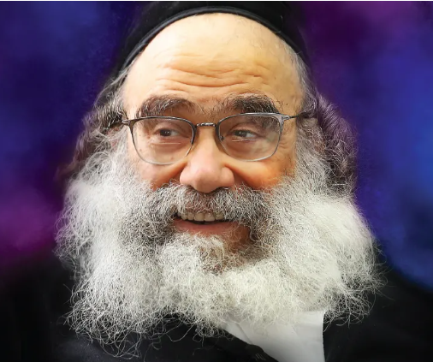

**Rav Gamliel Rabinowitz**

Rav Gamliel Rabinowitz, Shlit”a, relates that a number of years ago, there was a story circulating in Yerushalayim about an older Bachur, who approached one of the Tzadikim of the generation who had a reputation of being a Mekubal, who delved in the secrets of the Torah. The young man requested of the Tzadik that he Bentch him to find a proper Shidduch.

However, the Tzadik tried to evade him. When the young man saw that he was reluctant to give him a Brachah, he decided to insist on it, and he would not budge from his place. After a short while, the Tzadik said to him, “I am not able to do anything for you, because according to your Mazel, there is no Shidduch for you at all. I’m sorry.”

**The Bachur Left Confused and Upset**

The Bachur left there, confused and upset, and the next morning he returned to the Tzadik again to speak with him. The Tzadik took one look at his face and said, “Tell me the truth. What did you do last night?”

The young man responded, “Yesterday, when the Rav told me that there was no possible Shidduch for me, I went to Shul and stood next to the Aron HaKodesh and I cried bitterly all night long, and now I have returned.”

The Rav told him, “You should know that you have been saved in an extraordinary way! The Torah teaches us that if someone kills accidentally, he must go live in an Ir Miklat, a city of refuge, ‘until the death of the Kohein Gadol’, and the Mishnah (Makkos 2:6) relates that ‘the mothers of the Kohanim would supply these people with food and clothing, so that they should not Daven for their sons to die’.

“Everybody asks a question on this. Is it because of the food and drinks that the mothers supplied, that these people will stop Davening? They are in jail in that city! They can never leave! However, the answer to this is that even if they continue to Daven, their Tefilos will not come from the depths of their hearts. They still think about the food and clothing. When you spent the entire night crying and Davening, your Tefilos came from a completely broken heart, and those cries and Tefilos were heard and answered. I can now give you a Brachah for a Shidduch, and you will indeed get married very soon!”

**Every Person Must Realize the Need to Daven**

Within just a short while, this young man became a Chasan and was married soon after! Rav Gamliel explains that everyone has needs and issues that they are facing, and the main thing that we must realize is that a person needs to Daven. This doesn’t mean simply ‘lip service’, rather it is true Tefilah which comes from the depths of the heart. This rises and splits the sky until it reaches the Kisei HaKavod! This can be done for any matter that one needs help with, both physical and spiritual as well. Tefilah that emits from the depths of the heart is guaranteed to not come back empty!

*Reprinted from the Rosh Hashanah 5785 email of Rabbi Yehuda Winzelberg’s Torah U’Tefilah.*

**The Transformation of Just One Simple Mitzvah**

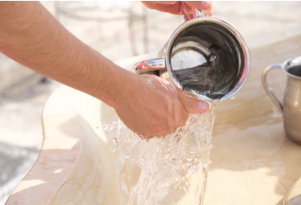

Horav Pinchas Cohen, Shlita (Rav of Nesivos, as related by Horav Yechiel Tzuker, Shlita), related the following story which underscores the extraordinary reward which can be garnered from a “minor” mitzvah. It also shows us what a simple, positive activity can achieve, when performed with sincerity.

The Rav was summoned to Ramat Gan to address a Sephardic family who had suffered a tragedy – a young member of their family passed away at a young age. Eidus HaMizrach (Sephardic tradition families, all (mourners, anyone related to the deceased) sit in a separate tent set aside for this purpose. They partake in a large, collective meal.

In this instance, when the Rav entered the tent, the people present expected him to speak. The family was mostly chiloni, non-observant, but traditional in adhering to some Sephardic customs. Rav Cohen began with the following admonition:

“You should know that the wonderful meal which you are all enjoying as part of your customary mourning does absolutely nothing for the neshamah, soul, of the niftar, deceased. He is in a different world where he is facing the Heavenly Tribunal. He can use all of the help that you can give him. Eating a meal does not help him. Performing mitzvos and carrying out acts of lovingkindness in his memory will help him in his moment of truth. If you care about him, you will accept upon yourselves to perform a mitzvah, regardless of its spiritual significance and subsequent reward. Just do something!”

A short while later, as he was about to leave, a young woman dressed inappropriately (according to Torah standards) came over and introduced herself. The deceased was her husband’s brother, and they were heartbroken over his passing. Could the Rav suggest a simple mitzvah, something meaningful but not difficult, to execute.

He suggested washing their hands upon rising in the morning and also prior to partaking of a meal consisting of bread. She agreed. He demonstrated the halachic procedure for netillas yadaim, handwashing. She thanked him and she said she would convince her husband to do the same.

Fast forward eighteen months. Rav Cohen was leaving his shul when a young woman, dressed in attire becoming a scrupulously observant woman, walked up to him and asked, “Does the Rav recognize me?”

He said, “I am sorry to say that I do not.”

“I am the woman whom you instructed to wash hands in memory of my brother-in-law. Well, it began with handwashing, and, as a result of a near tragedy, our faith was affirmed, and we became observant.” She then related the story. They had been deeply committed to observing the one mitzvah – albeit very simple, and they never missed an opportunity which required handwashing, to perform their mitzvah. At one point, they decided to go for a vacation; hiking in the mountains of India. They took along some bread and water and started their climb.

When they did not reach the designated campsite, they quickly understood that they had missed some of the landmarks that served to guide them. While they were not helplessly lost, they were out of water. As they looked around for some edible vegetation, they came upon a bed of mushrooms. They had bread and mushrooms. What more could a person ask for when he is lost? They checked the mushrooms, and they “seemed” to be the healthy type. The wrong mushrooms can be toxic and cause death.

The problem was that they had no water left with which to wash. The wife would not eat. She had given her word. The husband was famished and apparently not as strongly committed as his wife. He ate. Thirty minutes later, he was miserable. His wife called on the radio for any hikers in the area to help them and to pass the word on for emergency medical help.

Meanwhile, her husband went into shock, his breathing labored. It took an hour for a medical team to reach them, administer emergency help and drive him to the nearest hospital. For a few days, it was touch and go, but he recovered. Shortly after the ordeal, the husband woke up to the reality that he had become dangerously ill because he had reneged upon his commitment to one single mitzvah.

His wife did not eat, because she had no water with which to wash her hands. He turned to her and said, “Why are we playing games with Hashem? If one simple mitzvah could achieve so much, how much more so does it behoove us to transform our lives and become observant. That will be a true iluy neshamah, perpetuation of my brother’s soul.”

They attended Arachim seminars, studied the Judaism which, due to their upbringing, had been hidden to them – and they returned as bonafide Torah Jews. All due to the power of one simple mitzvah.

*Reprinted from the Parshas Eikev 5785 email of Peninim on the Torah compiled by Rabbi L. Scheinbaum for the Hebrew Academy of Cleveland.*

**The Special Pair of Tefillin**

**By Yehuda Z Klitnick**

The two heilige brothers, Rebbe Reb Elimelech of Lizensk, and Rebbe Reb Zusha of Honipoli, were also talmidim of the Magid of Mezritch. They traveled all around Europe in -exile- golus. Their main goal was to bring back people to teshuvah, to heed the Mitzvohs, and become G-d fearing people. They too didn’t go around talking to people day and night, rebuking them about their aveiros, and explaining to them that they must do teshuvah. Instead, they sat down for a few days in a town or village, and spent the time serving Hashem with their heilige avodah.

Through this avodah, they ushered a spirit of purity, into the hearts of all Yidden in that area until everyone in town did teshuvah. Harav Hakadosh Reb Avrohom Chayim of Zlotchuv writes in his sefer Mevaser Tzedek (Parshas Toldos):

**Influencing Jews to Do Teshuvah**

“I have heard in the name of Reb Zusha of Honipoli that when he wanted to bring back a man to good, he would fast, and otherwise cause pain to himself, and enter into a state of dveikus, deep, trance-like meditative state. He would continue to do this until he had influenced the man to do teshuvah.”

The Rebbe Harashab of Lubavitch told the following story. Once, the two heilige brothers arrived at an inn somewhere. The owner of the inn was an eighty-year-old man. Reb Zusha began to talk to himself, saying, “I have lived eighty years and never put on Tefillin!”

When the innkeeper heard this, he realized with a shock that in all his eighty years of life he had never had his Tefillin checked. He had the same pair of Tefillin that he had received at his bar mitzvah, and he had worn them every weekday in all those years, but he had never had them checked.

So, he gave his Tefillin to a sofer to have them checked. The sofer found the Tefillin posul. In fact, they were not Tefillin at all. Instead of the parshios inside, there were small pieces of wood!

The two heilige brothers decided they would stay and write new parshios for the Tefillin themselves. They put so much kedushah into the parshios that in the future when the Yid puts on these Tefillin he would rectify everything he had missed all the years he had failed to put on Tefillin.

The old Yid was able to put on the Tefillin once, as he was niftar that same day! A short time later, the Barditchiver Rov, Rabbi Levi Yitzchok, came to that same city without his Talis and Tefillin. He didn’t want to daven in a borrowed Talis

and Tefillin. So, he bought a new Talis and tied the Tzitzis on to them himself.

**Looking to Buy a Pair of Tefillin**

He went looking to buy Tefillin. In that town there was the custom that when a Yid was niftar, his heirs would give away his Tefillin to the chevra kadisha. It so happened that day, that they had several pairs of Tefillin they planned to sell at an auction. So, the chevra kadisha told the Barditchiver Rov that they have several pairs of Tefillin to sell. He could choose any pair, and pay as much as he wants for it.

When the Barditchiver Rov opened the box, his eye fell on one pair of Tefillin

that he liked very much, and he grabbed it and took it for himself. When he asked the chevra kadisha how much he needed to pay for the Tefillin, they told him to rather offer a price, and wait to see if anyone offers more than his bid.

Reb Levi Yitzchok had no choice and offered a price, and waited for others to offer another price. When someone offered a low price, the Barditchiver Rov offered a very high price of 300 ruble. When the Gabbay saw that the Barditchiver Rov really wanted that pair of Tefillin, he said to him, “I see the Rebbe wants that pair of Tefillin, so we will give them to the Rebbe for free, on condition that the Rebbe tells us the story behind that pair of Tefillin.”

The Barditchiver Rov told them how Rebbe Elimelech and Reb Zusha wrote the Tefillin for the innkeeper with great kavanos. When the old man was niftar, the people involved with the body were completely unaware of the importance of the Tefillin, and gave them away to the chevra kadisha.

“These very Tefillin they wrote for the innkeeper” finished the Barditchiver Rov. The chevra kadisha gave away the Tefillin as a gift, and the Barditchiver Rov was grateful that Hashem sent him such a helige pair of Tefillin. The Rov cherished the Tefillin, and saw the Hashgacha Pratis, that such heilige Tefillin ended up in the right hands.

*Reprinted from the Parshas Eikev 5785 email of Pardes Yehuda.*

**The Teshuva of Rosh Hashana**

**By Aharon Weinreb**

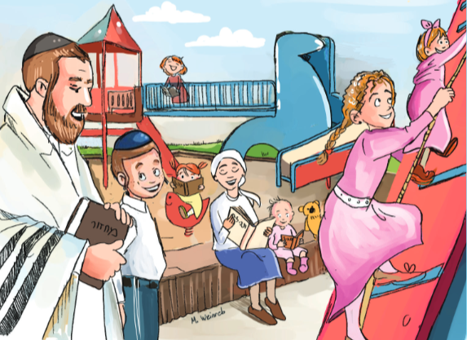

**Illustrated by Miri Weinreb**

**First Day of Rosh Hashana - after davening**

Yitzy and Shimmy waited patiently for Totty to finish saying Shir Shel Yom.

“Gut Yuntif, boys,” Totty smiled as he closed his machzor and they walked out of shul together. “How did you enjoy the davening?”

“It was amazing, Totty!” Yitzy said. “The baalei tefillah sang so beautifully and it really made the words come alive. I feel now more than ever that Hashem really is our King.”

“Yeah it was so special,” agreed Shimmy. “But I have a question. My rebbi told us that Rosh Hashanah is the first day of the Aseres Yemei Teshuva. But we don’t do any teshuva on Rosh Hashanah. We just say over and over again Hashem Melech, Hashem Moloch, Hashem Yimloch L’olam Va’ed. What does that have to do with teshuva? And also, why does Hashem need us to tell him that He is the King? It’s not like anyone else can be King besides him. And to say it over and over again? Why can’t we just say it a few times instead of repeating over and over again for hours?”

Totty adjusted the belt of his kittel as they took a shortcut through a path in the park. “That’s a great question, Shimmy! Rosh Hashanah is Yom HaDin - we’re being judged! So, we would think that the only thing we should be doing on Rosh Hashanah is teshuva. And yet, we instead spend the day davening that He should become our King.

“You know, I heard this question myself from Harav Avigdor Miller Zt”l at one of his Thursday night drashos. And he said the answer is that saying Hashem is our King is the biggest teshuva we can do! Because reminding ourselves that Hashem is our King is to remind ourselves that nothing in this world is important except for him. Money, cars, fancy silverware - it’s all nothing. Hashem is the only One that matters.”

Totty paused as they approached the monkey bars and slides. There on the bench was Mommy waiting for them, as Basya was trying to help little Yaeli climb the rope ladder. She was managing to get up the first couple steps, but then each time she would lose her footing and tumble into Basya’s arms.

“Gut Yuntif,” Tatty warmly greeted the rest of the family. “I think little Yaeli is helping us answer another question.”

Everyone looked at Totty in confusion as he continued. “I was just explaining to Shimmy how saying Hashem is our King is the best form of teshuva. But he also asked why we need to say it over and over.

“Take a look at Yaeli, Shimmy. Look how many times she is trying to climb that rope ladder? Why does she keep doing it?”

“Because she’s trying to learn how to climb,” said Shimmy. “If she does it over and over and over again, then she will learn how to do it.”

“Exactly!” Totty exclaimed as Basya scooped up Yaeli and the family began to finish their walk home. “And that’s why we need to say over and over again that Hashem is our King. It’s not enough to just say it once. We are so used to all of the gashmiyus around us that it’s hard for us to really Know that Hashem is actually our King and the most important One in our lives.

So, we need to practice in order to learn it well enough that it is actually real to us. And that’s why we spend the whole day repeating that “Hashem is our King, Hashem has been our King, Hashem should be our King forever.” And the more we get that message into our heads, the more we deserve to have a good year of Life!”

Have A Wonderful Yom Tov!

*Reprinted from the Rosh Hashana 5785 email of Toras Avigdor Junior, based on the Torah teachings of Rav Avigdor Miller, zt”l.*

**Davening on Rosh Hashana**

**in a Russian Forest**

It was a cold Russian morning in early September,1964 and the American Rav Braunstein was in Kiev once again. By 1964, Jewish communities in Russia barely resembled the vibrant Jewish life which had characterized Russia for so many centuries.

Communist Russia was a dangerous place where Jews were persecuted and killed and where Judaism was almost completely stifled. One sad example, thousands of miles of railroad tracks of the Russian railroad were literally laid down on the bodies of Jewish slave laborers who died in its construction.

Over the years, Rav Braunstein made several dangerous trips to Communist Russia, in order to perform bris milahs and to spread Yiddishkeit among the oppressed Russian Jews. Most of his work was done under fear of his life.

Several times the evil Russian police caught and beat Rav Braunstein. One time, after a particularly bad beating, when Rav Braunstein was near death, the Russians sent him to England on a special medical plane, in order that he not die in Russia. Thankfully, Rav Braunstein survived that beating and lived to return to Russia to continue his holy work.

One of the most memorable Rosh Hashanas that Rav Braunstein remembers is the Rosh Hashana he spent in Kiev, Russia in 1964. After the morning prayers on Erev Rosh Hashana, a Skverer Chassid approached Rav Braunstein and asked him if he would like to pray on Rosh Hashana with a special minyan of Jews in Kiev. (It is important to note that by this time after so many years of Russian persecution, Russian Jews for the most part lacked almost all external trappings of Judaism, although their hearts still beat strongly for Hashem.)

Rav Braunstein was intrigued by the offer of the Skverer Chassid and therefore he quickly agreed to join the minyan. Rav Braunstein was instructed to look for two men who would walk by his hotel the next morning at 7 a.m. The evil KGB was always lurking in the area, so the utmost care had to be taken to avoid detection. So, the Skverer Chassid instructed Rav Braunstein to carefully follow the two men, at such a pace so that nobody would notice that Rav Braunstein was following the men. It was only early September, but it was still very cold in Kiev, so Rav Braunstein was instructed to bundle up well.

Sure enough, the next morning at 7 a.m., as Rav Braunstein waited in the hotel lobby, two men walked by the entrance very quickly. As instructed, Rav Braunstein walked at a healthy distance behind the men.

The three, two ahead and one way behind, walked for what seemed like hours on that frigid winter morning. It was very cold and the walk was very long, yet Rav Braunstein walked with determination. Soon, Rav Braunstein and the others left the city and entered the fields surrounding Kiev.  Eventually, the group arrived to a small forest. At the entrance of the forest stood two righteous women. The Jewish women stood guard against unwanted visitors, such as the Russian police and the dreaded KGB.

As Rav Braunstein approached an opening in the trees, he noticed an amazing site. Several Jews milled around, some standing, some sitting on fallen trees which served as benches. This was the Rosh Hashana minyan, in the middle of a forest outside Kiev. This was a minyan made of up survivors, survivors of the evil Russian Empire. Rav Braunstein was amazed at what he saw…

The congregants huddled around what few machzorim there were, back in the cold Russian forest. Soon after Rav Braunstein arrived, a chassid began to lead the prayers. The minyan was made up of Skverer, Lubavitcher, Chernobler, and Breslever chassidim.

It was a davening that Rav Braunstein remembers to this day. Sitting nearby was an 80-year-old man who was too tired to stand up at all during the prayers. Apparently, the man had spent all his strength taking the long walk to the secret forest.

The old man sat on a log, in a talis which was in tatters; for new talesim and the like were not available in Communist Russia.

The old man sat crying on the log from ma tovu - the beginning of the prayers to Aleinu. Rav Braunstein watched in awe as the old man soaked his raggedy talis in tears.

Soon, it came time to blow the shofar. This was the most dangerous time for the secret minyan. The baal tokeah wanted to immerse himself in a mikveh before blowing the shofar, as is the common practice for many. Where would they find a mikveh deep in the Russian woods?

The baal tokeah went off to the side and undressed. He then proceeded to roll himself in the snow several times before getting dressed and rejoining the minyan.

The voice of the shofar had to reach up to the ears of the minyan and onwards to heaven without alerting the Russians of the holy congregation. So the baal tokeah sat on the forest floor while the minyan crowded around, squeezed together and hunched over him.

Because of the conditions, the baal tokeah had to blow the required 100 blasts one after the other, instead of the usual custom. As the voice of the shofar rose up to the ears of the members of the minyan huddled above, tears rained down on the baal tokeah. Fervent prayers sailed up to shomayim, asking Hashem for forgiveness and begging an end to the evil Russian Empire.

Having shed so many tears on that cold Russian day, Rav Braunstein left the minyan and trudged back to Kiev. It was a Rosh Hashana he would never forget. Nearly 25 years later, the Iron Curtain and the Communists finally came down; at least partly on the power of that secret minyan in a forest outside of Kiev in 1964. (as told by Rav Yosef Chaim Greenwald) As long as the voice of Yakov is heard in prayer, Yakov - Yisroel will prevail.

*Reprinted from the Parshas Toldos 5785 email of Good Shabbos Everyone.*

**The Helpful Fly**



Rav Gamliel Rabinowitz related a story in Tiv HaHashgacha that someone had reported: My nine-year-old son excitedly told me a story that happened to him in the middle of the Haftorah on the first day of Rosh Hashanah. He said, “I lost the place in my Machzor during Maftir. I looked for the place, but I could not find it. Suddenly, a fly landed on my Machzor, and I was about to wave it away, when I realized that it was standing on the exact place where the Ba’al Korei was reading! I was then able to follow along!”

I was touched by two points in the story. The first point was to hear the story from my son, in that he was able to see the Hashgacha Pratis of Hashem in the entire story, and how Hashem is running the world from the biggest to the smallest details. The second point is that he patiently waited until between the Haftorah and Mussaf, and only then did he tell me the story, despite being excited and wanting to tell me the minute it happened. I believe that this is the nature of most of Am Yisroel, not to speak during Davening and Leining!

*Reprinted from the Rosh Hashanah 5785 email of Rabbi Yehuda Winzelberg’s Torah U’Tefilah.*

**A Few Days of Closeness to Hashem**

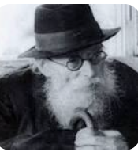

**The Chazon Ish**

Rav Avraham Pollak, zt”l, the Mashgiach of Slabodka, once asked the Chazon Ish, zt”l, “Why do we go through the process of doing Teshuvah in Elul and during the Yomim Nora’im? When Cheshvan comes around, we will be back to our old selves again!” The Chazon Ish answered, “It’s all worthwhile for a few days of closeness to Hashem!”

*Reprinted from the Rosh Hashanah 5785 email of Rabbi Yehuda Winzelberg’s Torah U’Tefilah.*

**The Great Spiritual Awakening**

The Rambam says the shofar leads to a great spiritual awakening. There is a story about a boy who went off the derech. He took money from his parents and moved out of their house. Two years later, on Rosh Hashanah, he was walking around the city, smoking and drinking with his friends.

A man with a kippah approached the group and asked the boy if he would like to hear the shofar and the beracha. The boy agreed so that he could make fun of the man with his friends. But when the boy listened to the crying, inspiring sound of the shofar, he was suddenly overwhelmed with the desire to return home to his parents.

He walked a long way from Manhattan over the bridge to Brooklyn to tell them he wanted to come back home. As he walked into the house, he saw his entire family waiting to eat the Rosh Hashanah meal with a plate set for him at the table. The boy and his parents broke down in tears. His mother and father were waiting for him to come home all this time with open arms.

All year, or even all our lives, we may have transgressed and turned away from Hashem. All we have to do is tell Hashem, our Father in Heaven, one thing: “I want to come home,” and He will take us back with open arms and forgive us. But we are responsible for taking that first step! On Rosh Hashanah, we must recognize Hashem as our Melech HaMelachim—King of Kings. Even though we keep doing the same sins repeatedly, even if it has been a thousand times, Hashem is still our Av, our Father in Heaven, waiting for us to return.

*Reprinted from the Rosh Hashanah 5784 email of Jack E. Rahmey based on the Torah teachings of Rabbi Amram Sananes.*

**A Near Fatal Rosh**

**Hashana Faint**

**From the Desk of Yerachmiel Tilles**

**I** [**Dr. Les Rosenthal**] am a dentist; I have a practice in Encino, California. I also have a good singing voice and dabble in cantorial music. In 1981, I was asked to sing at a synagogue north of Los Angeles. The hall was full-probably 1,500 people were there-and I had a solo to sing, the prayer *Unesaneh Tokef*. One bar before the solo, a massive headache struck me and I fell to the floor-they had to carry me off the bimah (platform) in the middle of Rosh Hashanah.

I was taken to a room where I could lie down and rest for a while. But two hours later, the headache had not gone away, its intensity was unchanged, and it was clear this was not a good thing.

At that point I was taken to the hospital, where they took x-rays of my skull and neck, and came back with the diagnosis, "You have a tumor in the pituitary gland. It's destroying the bone, and the pressure is causing the headache."

A neurologist was called in, who ordered a tomograph in order to get a better picture of the bone destruction. After he got the results, he said, "There is no tumor. There is no destruction of the bone."

Relieved, I thought, "That's good-I'm going home!"

But he said, "Since we do not have a cause for your headache, we need to do further tests." He ordered a CAT scan.

The CAT scan revealed that behind my right eye, in the middle of the gray matter, I had an aneurysm-a blood vessel that had blown up like a balloon-and it was about ready to burst. If it burst, death would be instant.

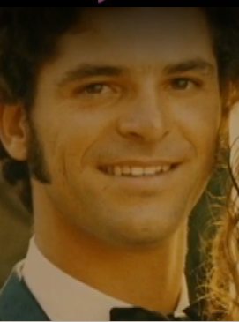 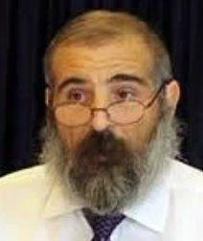

**Dr. Les Rosenthal and Rabbi Joshua Gordon**

When my wife heard that, she became hysterical. She was pregnant with our third child, and the idea of being alone with three young kids without a husband scared her witless.

She began to push me to go the next step-an aortic angiogram-which the neurologist recommended. This involved putting a catheter into a major artery in my leg and feeding it up to the aorta, then releasing a dye. This test allowed the doctors to map where the blood vessels are, and see if it was possible to stop blood flow to that particular blood vessel with the aneurysm.

If so, then they could make a hole in my head or else remove the eye to get to the affected area, and then they could put metal clips there so that the aneurysm wouldn't burst. While that might sound good, the problem with such a procedure is that the particular blood vessel could be feeding some vital part of the brain, and once it is clipped off, a stroke could result. That did not sound like a risk I wanted to take.

There was another option, which unfortunately did not sound much better. This called for surgically exposing the aneurysm and coating it with glue to reinforce its walls. In this procedure the surgeons would have to destroy a lot of tissue to expose the aneurysm, and that could also cause a deficit in brain function.

Neither of these options sounded good to me, but my wife was very upset and pushing the doctors to do something. Finally, I told them, "Okay, we'll do this. But only on the condition that, if you're going to do the aortic angiogram, you must have an operating room ready, so you can move me and do the next procedure. If I ever wake up, I want it to be over."

Everyone agreed, and that's when Rabbi Joshua Gordon stepped in. He was the director of Chabad of the Valley, and we had taken advantage of his Shabbat hospitality a number of times. At his table, we heard about the **Lubavitcher Rebbe**, and we attended classes where the Rebbe's teachings were discussed.

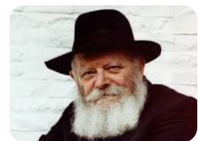

**The Lubavitcher Rebbe**

Rabbi Gordon said to me, "You have to write the Rebbe a detailed letter about what's going on here. You have to ask him for a blessing."

While I was moving toward Torah observance, I was still skeptical about the mystical aspects of Judaism, and I didn't know what good a blessing could do. I said to him, "Listen, it's not my thing! I mean, what does an old Jew, 3,500 miles away, know about what's going on in my head?"

I know that sounds pretty disrespectful, but that's where I was coming from at the time. Rabbi Gordon's comment was, "Why not write the letter? What harm could it do for you to write it? You will be asking for a blessing from a very great man, who has given blessings to many, many people who-as a result of his blessings-have had wonderful things happen in their lives."

So, I relented. I surprised myself by writing a three-page letter by hand and sent it off.

Four days later, the answer came in the form of a phone call to Rabbi Gordon. Essentially, the Rebbe's message to me was, "There is nothing wrong with you. If you have to take this last test for your own peace of mind, I give you a blessing that it should be successful. But there's nothing wrong with you."

Since I had already decided to do the aortic angiogram, I went through with it. When I woke up I saw, standing over me, the radiologist who specializes in reading neurological films. His faced look very somber, almost miserable.

But I was happy. The very fact that I woke up made me happy. I could think! I could see! I could speak! I didn't care about anything else.

The radiologist stared at me for a few moments, and then he said, "I've never seen anything like this before-that something so clear on a CAT scan should turn out to be absolutely nonexistent in an aortic angiogram. You are fine. You have absolutely nothing wrong with you at all. I have no clue why you had that headache."

The bottom line is-I haven't had that headache since. Not since 1981, thirty years ago.

Afterwards, we threw a big party catered by one of the kosher restaurants in Los Angeles, since our house was not kosher enough as yet. My neighbors thought I had died and it was a wake, because they saw all these black-hatted rabbis coming over. But then they saw me dancing in the street, celebrating this miracle.

It didn't take more than that to make me Torah-observant and a chassid of the Rebbe and of Chabad, which I am to this day. My whole family was profoundly affected as well. All our kids attended *yeshivahs* and seminaries,[1] and today, everyone in the family keeps Shabbat, keeps kosher. They all lead religious lives. And we are now expecting our fifteenth grandchild.

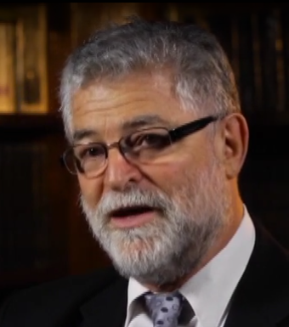

**Dr. Les Rosenthal (circa 2011)**

This whole level of *nachas* would not have been mine if it wasn't for the Rebbe. He sent me-whom he had never met, and who knew nothing about him-such a salvation blessing.

***Source*:** Lightly edited and supplemented by Yerachmiel Tilles from a weekly email of "Here's My Story," a part of JEM's *extraordinary* "My Encounter with the Rebbe" project.  
**Dr. Les Rosenthal** practices dentistry in Encino, California. He was interviewed in his home in September 2011. The text of the video was published online in 2015. A video of him telling the story can be found at https://www.chabad.org/3507814.

Why this Week: The story begins on **Rosh Hashana** (1981)

Biographical note:

*Reprinted from the 5785 email of KabbalaOnline.org, a project of Ascent of Safed in Israel.*

**Rav Chaim Kanievsky’s Advice to a Childless Couple**

Rabbi Joey Haber shared a story:

A relative of mine, who studies in a Kollel in Lakewood, personally told me the following. Like many of his friends, he is married with a family, as is the case for those learning in Kollel. However, one of the other Kollel members had been married for five years and hadn’t been blessed with children. With the many other young men and women taking note of this, endeavoring in every which way to be supportive, encouraging and helpful to this young couple became a collective undertaking.

Special efforts in Davening and other forms of emotional support were extended in the hopes of easing the couple through their moments of challenge and eliciting Hashem’s Brachah. Significant resources were similarly poured into being there for them, and this couple didn’t take it for granted by any measure. They knew how much everyone else around them was at their side and behind them.

In fact, the husband was so appreciative and good natured that after a member of the Kollel had their fourth child, he opened his home to the Kollel member’s family and hosted the Shalom Zachor on the Friday night before the bris.

The members of the Kollel absolutely loved this man, so much so that they decided to arrange for someone to make a visit to Rav Chaim Kanievsky, zt”l, and ask for a Brachah. Entering Rav Chaim’s personal study, the circumstances were explained. Rav Chaim advised as such:

“Let all the friends gather for the purpose of helping one irreligious Jewish child obtain a Torah education. Since you are aiming to help this man and his wife bring a Neshamah into this world, do something Middah K’Neged Middah, measure for measure. Help a child who is not religious receive a Jewish education, through which he will become religious. By doing so, you are enabling a Neshamah to return to Hashem, and through that, may Hashem grant this man and his wife the Brachah of meriting to bring a Neshamah down to this earth. Do this, and watch what Hashem does.”

On January 7, 2020, the boy who was chosen to enter a Jewish school to receive a Torah education began his studies at a Yeshivah. And just under a year later, on January 6, 2021, this man and his wife had a baby boy. My relative, at the time he related this story to me, said, “I’m now on my way to the Bris, and Joey, I just needed to tell you this story.” Hashem runs the world. That’s all there is to say. Every aspect and facet of it, calculated down to the smallest minutiae and precise detail!

*Reprinted from the Parshas Shoftim 5785 email of Rabbi Yehuda Winzelberg’s Torah U’Tefilah.*

**Just Learn for**

**Ten More Minutes**

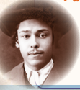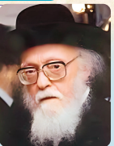

[Rav] Yosef Shalom [Elyashiv] grew up during a tense time in Yerushalayim. It was before the founding of the State of Israel, and the country was ruled by the British. While Jews were allowed to visit the Kosel, they were not allowed to bring holy objects there. Blowing the shofar on Rosh Hashanah was certainly forbidden.

Some of the young boys in Yosef Shalom’s shul were not happy with this situation and wanted to take action. On Rosh Hashanah, after davening was over, one of them planned on sneaking a shofar into the Kosel area and blowing it there. Even though the plan was really dangerous and he would be arrested if caught, the boy still intended to go ahead with it.

Yet not all his friends agreed with his idea. The boys continued to debate the plan. They were standing right outside the shul where Yosef Shalom was sitting and learning. He heard both sides and really wanted to join the discussion. He didn’t want to miss out. But he knew he should be learning and not wasting time.

So, he told himself, “You can go. Just learn for ten more minutes, and then go.” After ten minutes passed, he told himself again, “You can go. Just learn for ten more minutes, and then go.” One ten-minute time period led to another, and he kept pushing off going out to join the conversation. Eventually, he became more and more involved in the learning and no longer wanted to join.

*Reprinted from the Parshas Eikev 5785 edition of At the Artscroll Shabbos Table.*

*Excerpted from the ArtScroll book – “When They Were Young: Stories of Our Gedolim as Children” by Rabbi Yerachmiel Garfield.*

**Rav Yosef Shalom Elyashiv**

Yosef Shalom Elyashiv was born in 1910, in Shavel, Lithuania. He was the only child of R’ Avraham and Rebbetzin Chaya Musha Elyashiv (his father took his mother’s last name). His mother was the daughter of the famous mekubal, R’ Shlomo Elyashiv, known as the Leshem (after the sefer he wrote).

In 1924, the Elyashiv family moved to Yerushalayim. Yosef Shalom learned in the Yeshivas Etz Chaim in Yerushalayim. He spent the rest of his life in Yerushalayim. In 1934, at the age of twenty-four, Yosef Shalom married Sheina Chaya, the daughter of R’ Aryeh Levin, who was known as the tzaddik of Yerushalayim.

In 1948, he was appointed a dayan on the Beis Din of Yerushalayim. Throughout his life he learned with hasmadah and was an expert in halachah. His reputation as a leading halachic authority grew. He became known as the posek hador, the posek of the generation, until his petirah in 2012.

*Reprinted from the Parshas Eikev 5785 edition of At the Artscroll Shabbos Table.*

*Excerpted from the ArtScroll book – “When They Were Young: Stories of Our Gedolim as Children” by Rabbi Yerachmiel Garfield.*